The fine print…
A detailed confirmation will automatically be emailed to you once your registration has been submitted. You may choose to pay by credit card when registering or pay by check from the invoice that is generated. Full payment is required by Monday, August 18, 2025. The Cancellation Policy will be enforced once your registration is submitted (with or without payment). If you have any questions, contact the Central Office at info@pathassist.org.
Important Note: If you register for the conference under the "shared or individual room" rates but are unable to secure hotel reservations at the Hyatt Regency Denver at Colorado Convention Center, you will be invoiced for the conference registration difference. We ask that if you have any trouble making reservations at the host hotel, please contact the AAPA office before making reservations elsewhere.
Registration Options
- Full Conference: Fee includes access to breakfast, coffee breaks, all lectures, poster sessions, exhibitor session, and credits awarded based on attendance requirements. Lunch and dinner for the week are not included. Registrants have the ability to earn up to 23 PACE credits by attending 17 lectures and three poster sessions (two quizzes per session)! Register by August 23, 2025, for the best available rate!
  - Full conference (individual room) = individual room booked at the host hotel. Not sharing with another registered conference attendee.
  - Full conference (shared room) = room booked at the host hotel shared by one or more registered conference attendees.
- Daily Attendance: Fee includes access to lectures offered on the day(s) registered, breakfast and coffee break, social events (if applicable), and PACE credits based on attendance requirements for the day(s) registered. Lunch and dinner are not included.
- Add Workshop to Full Conference or Daily Attendance: Fee includes access to the workshop, and PACE credits based on attendance requirements.
- Workshop Only: Fee includes access to the workshop on Thursday only, and PACE credits based on attendance requirements. No meals are included.
Registration Fees
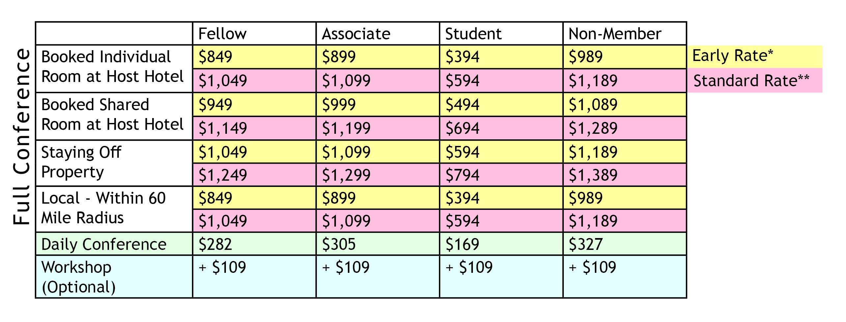
* Early Rate = By August 23, 2025
**Standard Rate = After August 23, 2025
Registration Changes
An additional $75 fee will apply to ALL adjustments made to your conference registration after it has been received. This applies to daily registration changes and optional activity cancellations/transfers, unless otherwise noted in the activity description. As space permits, you may add events to your registration at no additional charge.
Cancellation Policy
Written notice to cancel must be received via mail or email by or on August 18, 2025, to receive a full refund. Cancellations due to active military duty will be fully refunded. Cancellations made on or between August 19, 2025, and August 29, 205, will be issued a refund of 80%. No refunds will be given on or after August 30, 2025. For cancellations due to illness after August 30, 2025 a refund of 80% will be given with the submission of a physician's note. Any changes made to a registration will incur a $75 administrative fee. If the AAPA cannot hold the conference due to acts of God, war, government regulations, disaster, strikes, civil disorder, or curtailment of transportation or other emergencies making it inadvisable, illegal, or impossible to provide the facilities or to hold the meeting, each prepaid registrant will receive a copy of conference handouts and any other materials that would have been distributed. Fixed conference expenses will be paid from the pre-registration funds. Remaining funds will be refunded to pre-registrants. AAPA is not responsible for any other costs incurred by pre-registrants in connection with the conference.

